**LAB EXPERIMENT 6**

**Aim:** To study the working and outputs of the 3:8 decoder in XILINX software and check it’s output in the ISIM simulator.

**Theory:**

3:8 Decoder: A decoder is a combinational circuit which is used to change the code into a set of signals. It is the reverse process of an encoder. A decoder circuit takes multiple inputs and gives multiple outputs. A decoder circuit takes binary data of ‘n’ inputs into ‘2^n’ unique output. In addition to input pins, the decoder has a enable pin. This decoder circuit gives 8 logic outputs for 3 inputs and has a enable pin. The circuit is designed with AND and NAND logic gates. It takes 3 binary inputs and activates one of the eight outputs. [3 to 8 line decoder circuit](https://www.elprocus.com/designing-4-to-16-decoder-using-3-to-8-decoder/) is also called as binary to an octal decoder.

Circuit Diagram: The decoder circuit works only when the Enable pin (E) is high. S0, S1 and S2 are three different inputs and D0, D1, D2, D3. D4. D5. D6. D7 are the eight outputs.

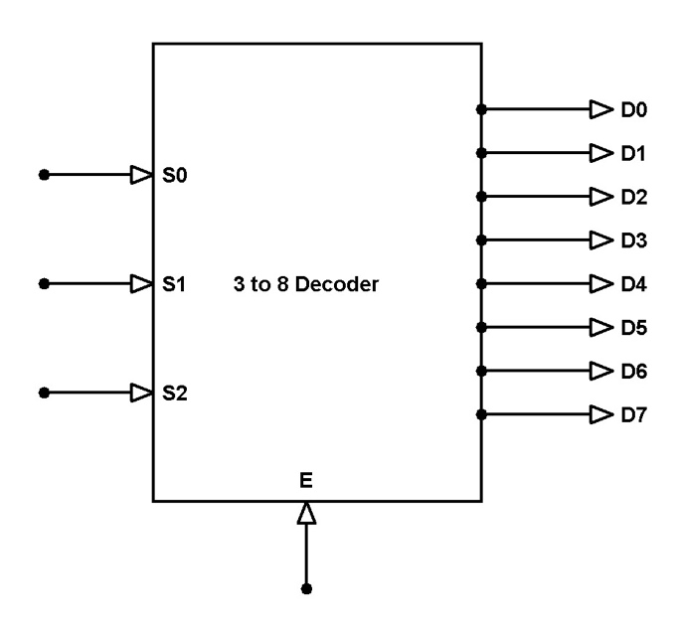

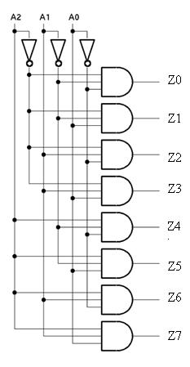

Truth Table:

**Verilog Code of the program and output:**

1. **Verilog Code of the Program:**

module decoder3to8_DFM_Rahil_062(

    output o0,

    output o1,

    output o2,

    output o3,

    output o4,

    output o5,

    output o6,

    output o7,

    input a,

    input b,

    input c

    );

assign o0 = ( ~a& ~b& ~c);

assign o1 = ( ~a& ~b& c);

assign o2 = ( ~a& b& ~c);

assign o3 = ( ~a& b& c);

assign o4 = ( a& ~b& ~c);

assign o5 = ( a& ~b& c);

assign o6 = ( a& b& ~c);

assign o7 = ( a& b& c);

endmodule

1. **Screenshots of the Output:**

1. **RTL Schematics:**

**Conclusion:** From this experiment we learnt how to implement a 3:8 decoder in the XILINX software. We used the data flow type of modelling in this experiment. We also learnt how to check the output from the truth table.